Tasks: Micro-Blogging

Go to

- https://twitter.com/AMarch4OurLives
- https://twitter.com/Emma4Change
- https://twitter.com/davidhogg111

Pick at least three tweets.

- Analyze these tweets.

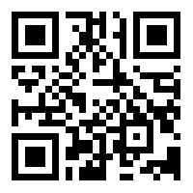
- The survivors of the Stoneman Douglas High School shooting, on February 14th, 2018 have organized the #MarchForOurLives in Washington D.C. on March 24th, 2018 and are now touring the country to register young voters. In addition, they use social media to make their voices heard.

For an analysis of their use of social media, visit “The March For Our Lives Was Born on Social Media“: https://www.crimsonhexagon.com/blog/march-for-our-lives-was-born-on-social-media/ (short link: https://bit.ly/2kTs2hu).

Do further research on their use of social media for their political cause.
Examine their use of:
  - hashtags (#MarchForOurLives, #NeverAgain, #WhatIf, #WeCallBS, …)
  - instagram (https://www.instagram.com/marchforourlives/)
  - youtube (https://www.youtube.com/channel/UC77-uGJRVBiXou-G6S7_4yQ [short link: https://bit.ly/2sBX0iy])
  - (if possible) snapchat

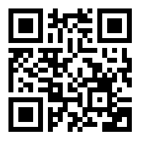
2a. Compare and contrast their use social media to the use of social media by the NRA, supporters of the 2nd Amendment.

You may use Hill, Selina: “5 shocking and outrageous responses to March For Our Lives“, http://www.blackenterprise.com/5-outrageous-responses-march-lives/ (short link: https://bit.ly/2Lw1HS7) as a starting point of your examination.

- Discuss advantages and challenges of the use of social media in political protest.

- Engage with people on a social network about your political cause, using a hashtag.

