Definition: Internet Memes
Memes are a worldwide social phenomenon. “A 'meme' is a virally-transmitted cultural symbol or social idea.“ “These small movements tend to spread from person to person via social networks, blogs, direct email, or news sources.“ “The majority of modern memes are captioned photos that are intended to be funny, often as a way to publicly ridicule human behavior. Other memes can be videos and verbal expressions. Some memes have heavier and more philosophical content.“ Since 2016 memes have played an increasing role in political debates online.

‘Meme' comes from the Greek word ’mimema' (meaning ’something imitated’, American Heritage Dictionary). Richard Dawkins - an evolutionary biologist - described memes as being a form of cultural propagation, which is a way for people to transmit social memories and cultural ideas to each other. In reference to evolutionary principles, memes - like genes - replicate successfully, evolve through alteration or mutation and spread; unfit memes are forgotten. Due to the rapid transformation of internet memes, their analyses are complex.

Although seemingly simple, memes are complex signs, which need a deeper understanding of contextual cultural knowledge of the image and the references in the captions.

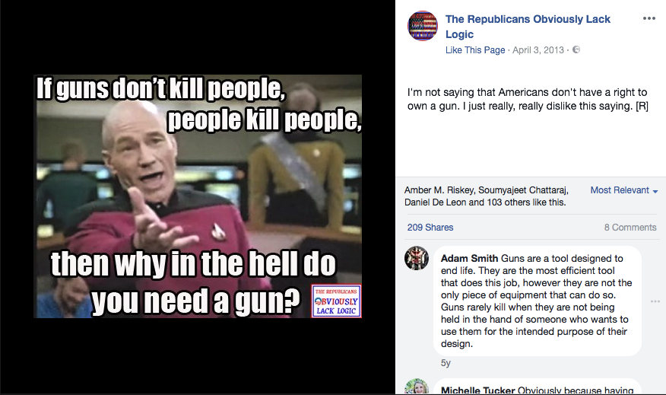
TOP TEXT

image

BOTTOM TEXT

typical image macro of an internet meme | example of a political internet meme

How to: Analyze Internet Memes

Screenshot of Facebook profile “The Republicans Obviously Lack Logic“: https://www.facebook.com/TROLLGOP/photos/a.306620502769573.68342.306616749436615/394041124027510/?type=3&theater, 6/6/2018

Step 1: Introduction
- Give available information on the context (name of person who published the meme, date and place of publication, number of likes or shares or any other kind of additional information).
- Identify the main issue the meme refers to.

Step 2: Description
- Describe the image (setting, objects, people), the action depicted and the caption.
- If possible, describe the comments in the comment section of the platform on which it was published.

Step 3: Analysis
Explain the main message of the meme and how it is created. To do this, analyze…
- the image. Use your background knowledge and, for example,
  - “The Rhetorics of Memes“, a project by the University of Michigan: https://sites.google.com/a/umich.edu/the-rhetoric-of-memes/home (short link: http://t1p.de/51t2)
  - http://knowyourmeme.com
- (if possible) additional allusions, e.g. symbols: “Scumbag hat“, background color, …
- the caption and the use of (non-standard) English,
- the connection between the image and the caption,
- the intended audience.

Step 4: Evaluation
Evaluate the effectiveness of the meme. Determine what makes the meme sharable: irony, exaggeration, new perspective, choice of words, analogies, …

Go further:

Research
- In order to combat “fake news“, determine the meme’s trustworthiness by comparing and contrasting the message of the meme with other sources.

Create your own memes
- Inform yourselves about the newest memes: https://www.reddit.com/r/memes/.
- Browse through memes and gifs: https://giphy.com/search/memes/.
- Generate memes with the most popular images; upload your own images and memes, e.g.: https://imgflip.com/memegenerator, https://memegenerator.net.

Gil, Pauli. “What is a meme?“, https://www.lifewire.com/what-is-a-meme-2483702, 6/6/2018.
wikipedia, “internet meme“, https://en.wikipedia.org/wiki/Internet_meme, 6/6/2018.
Gil, ibd.
cf. Osnos, Evan. “The Year of the Political Troll“, https://www.newyorker.com/news/daily-comment/the-year-of-the-political-troll and Priceonomics Data Studio, “We Analyzed Every Meme on the Internet“, https://priceonomics.com/we-analyzed-every-meme-on-the-internet/, 6/6/2018.
screenshot of Facebook profile “The Republicans Obviously Lack Logic“: https://www.facebook.com/TROLLGOP/photos/a.306620502769573.68342.306616749436615/394041124027510/?type=3&theater, 6/6/2018.

