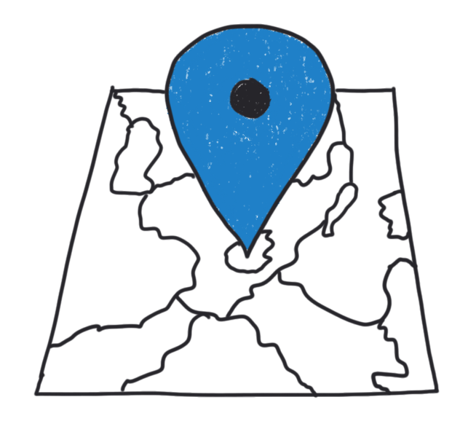
Welcome to Hamburg

Help your pen pals learn about your city. In a digital map, tell them more about Hamburg’s must-sees and share your favourite places.
CC0
1
Choose your sights

- Make a list of the sights and places you want to write about:
  - What sights should your pen pals visit? What should they do in Hamburg?
  - Do you have any favourite places (parks, restaurants, museums, …)?
- Homework: Take pictures of your places. You can add them to your map later.
Don’t take pictures of people!

2
Create your map

- Use Google My Maps to create your own map.
- Tell your pen pals as much as possible about the places you have chosen:
- Tell them what you can do or see there.
- Give reasons why you like the place.
- Use adjectives to make your texts more interesting.
- If possible, add some fun facts.

Example: The “Stadtpark” is one of Hamburg’s prettiest parks. It is a great place on a warm summer day. You can have a picnic and relax or play football. There are also playgrounds and a lake where you can rent a paddle boat and explore Hamburg by boat. My favourite place in the “Stadtpark” is the planetarium because there are always special shows for kids and…

Useful phrases
- …is the largest/smallest/highest/… in Hamburg  - … is my favourite place because…  - … is Hamburg’s/the world’s most famous…  - It’s a fantastic/an amazing place for…  - About … hundred/thousand/million visitors come here each day/year/…  - … is good for someone who likes… | - … is a great place for/if you want to…  - There you can see…  - … has a lot of different activities for children of all ages.  - Every Saturday/Sunday/… you can…  - You can get there easily on foot/by…  - … doesn’t cost anything.
3
Share your map

- Use the checklist. Edit (überarbeite) your work if necessary.
- Share your map with your pen pals.

