Assignment

**Analyze Donald Trump’s use of language in his tweets**.

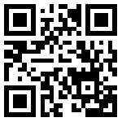<https://zumpad.zum.de/>

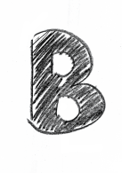

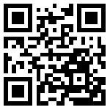<https://literary-devices.com/>

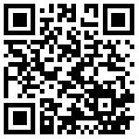<https://twitter.com/realDonaldTrump>

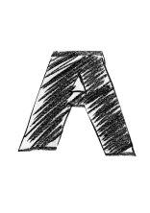

* Work with your partner and browse through the Twitter feed of @realDonaldTrump. [QR-Code A]
* Pick about ten tweets and identify stylistic devices. [QR-Code B]
* Analyze them regarding the effect that is created.
* Collect your findings in a ZumPad. [QR-Code C]



* Work on your own.
* Write an analysis to each tweet.

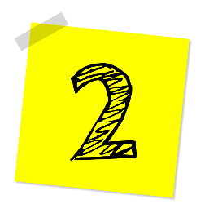

* Present your audio clip to the class.



* Prepare an expert interview with your partner.
* Rehearse the interview.
* Record the interview using a smartphone app.

