Reading Journal

Name: __________________________

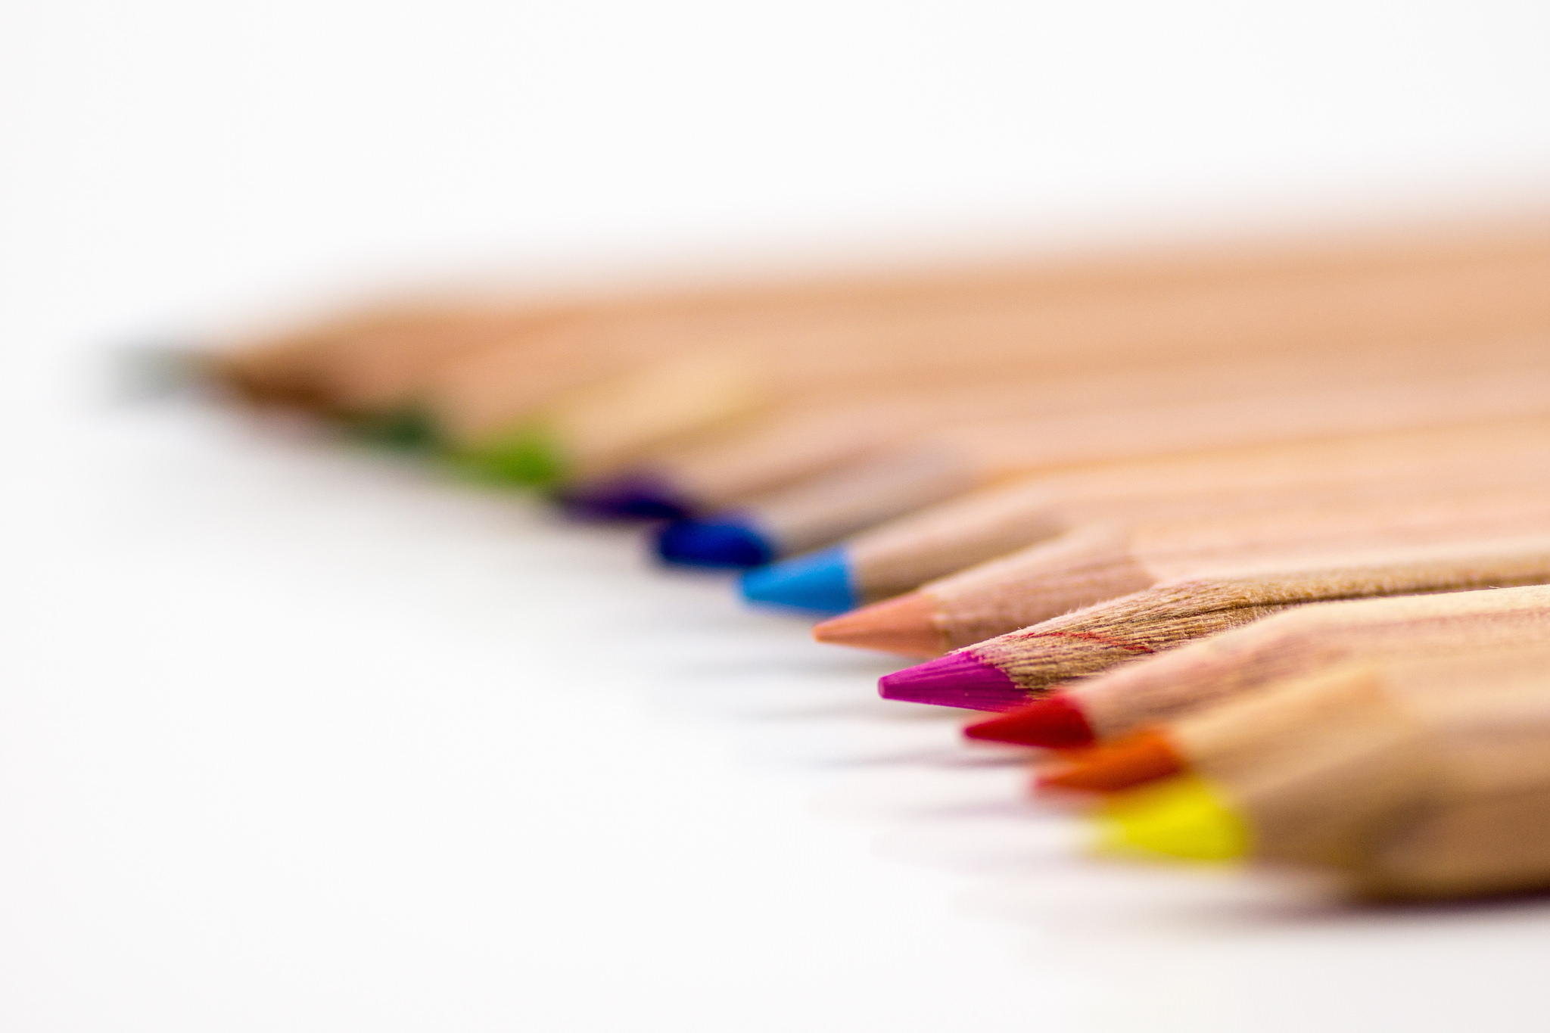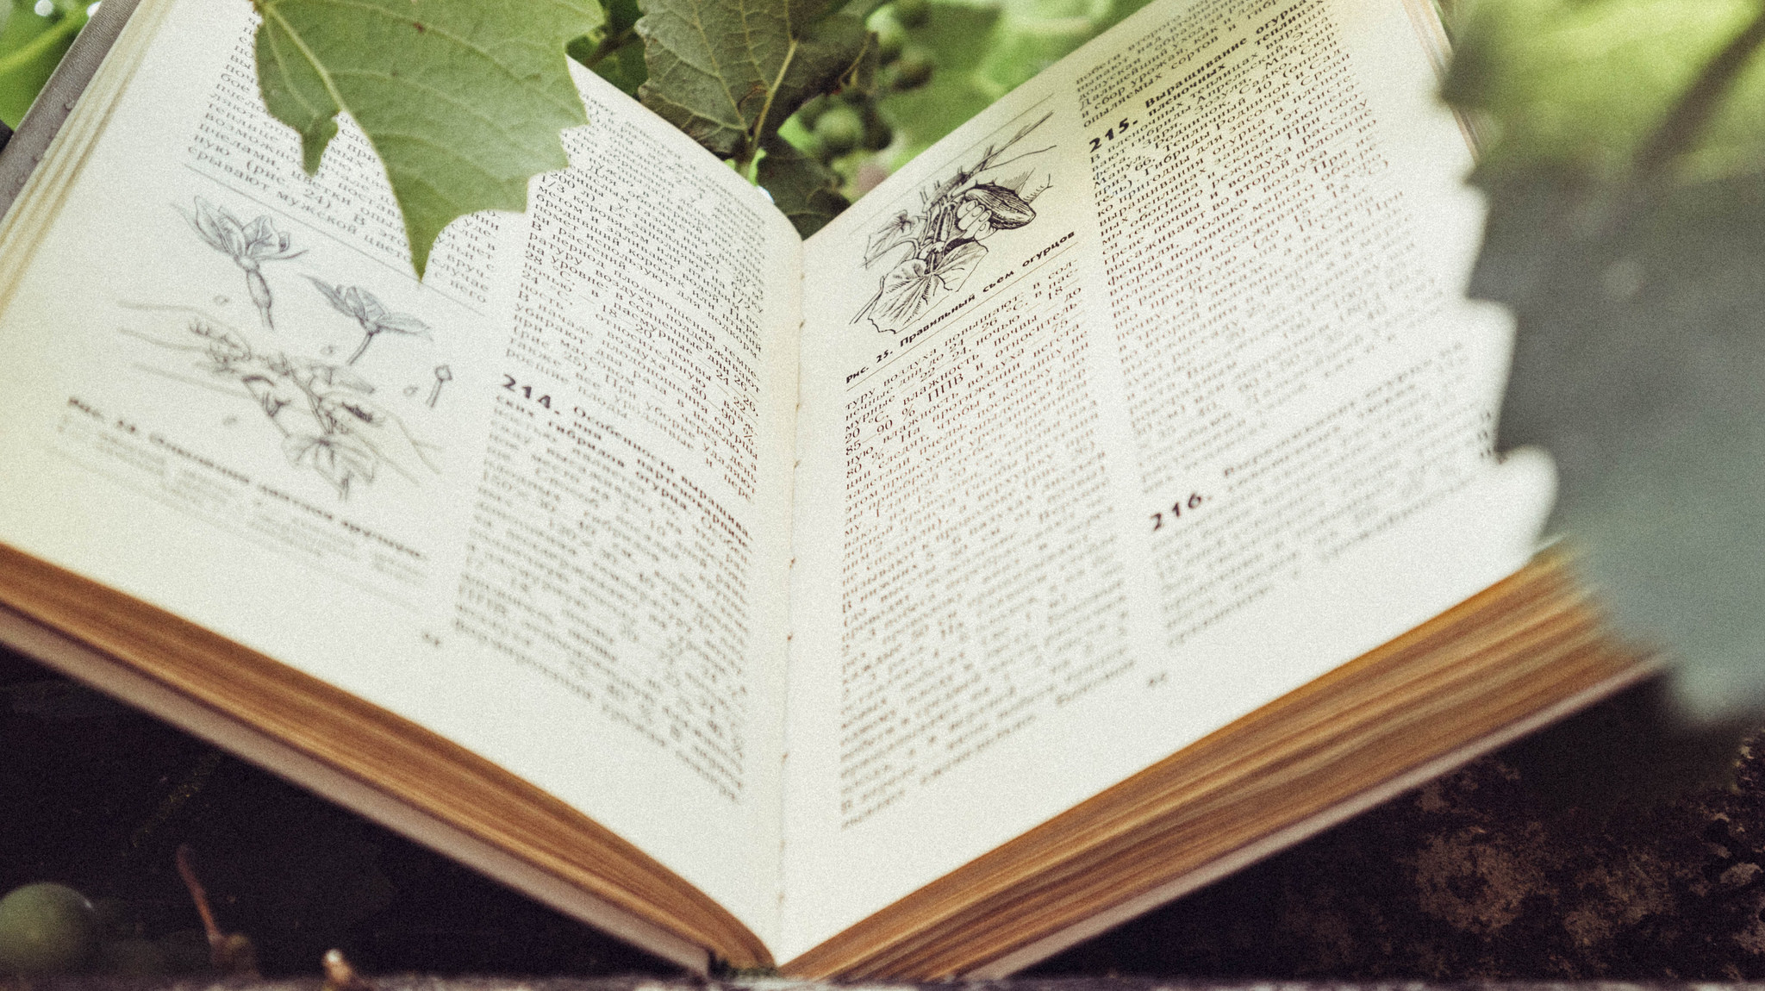

Reading Record

I read these books.

| Date | Book Title |
| --- | --- |
|  |  |
|  |  |
|  |  |
|  |  |
|  |  |

Characters from the book

Draw four characters from our book. Write their name under the picture.



A new book

Answer these questions about your book.

|  |  |
| --- | --- |
| What is the title? |  |
| Who is the author? |  |
| What does the picture on the cover show? |  |
| What do you think the book will be about? |  |

The setting

Draw a picture of a setting in the middle of the page. In the boxes around the picture write down some good words to describe the setting.

The Main Event

Draw a picture of the main event in your book. Then describe what is happening in your picture.

What is happening?

Look for words that end in ‘ing‘ in your book. ’ing’ words show what is happening.

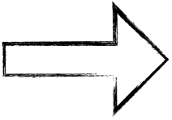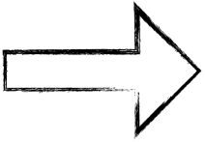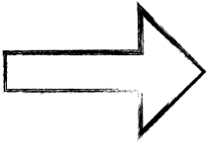

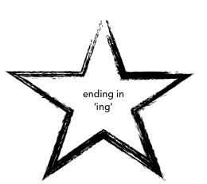

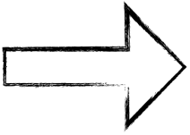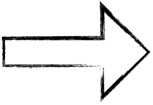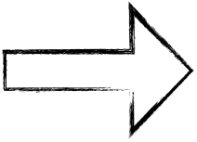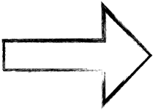

Who, where,   
when and what?

Try to remember and retell what happened in your story.

|  |  |
| --- | --- |
| What happened in the story? |  |
| When did the story happen? |  |
| Where did the story take place? |  |
| Who was in the story? |  |

What would I do?

Imagine you were the main character in the story. What would you do, if you were in their situation?

|  |
| --- |
| If I …………I would……. |

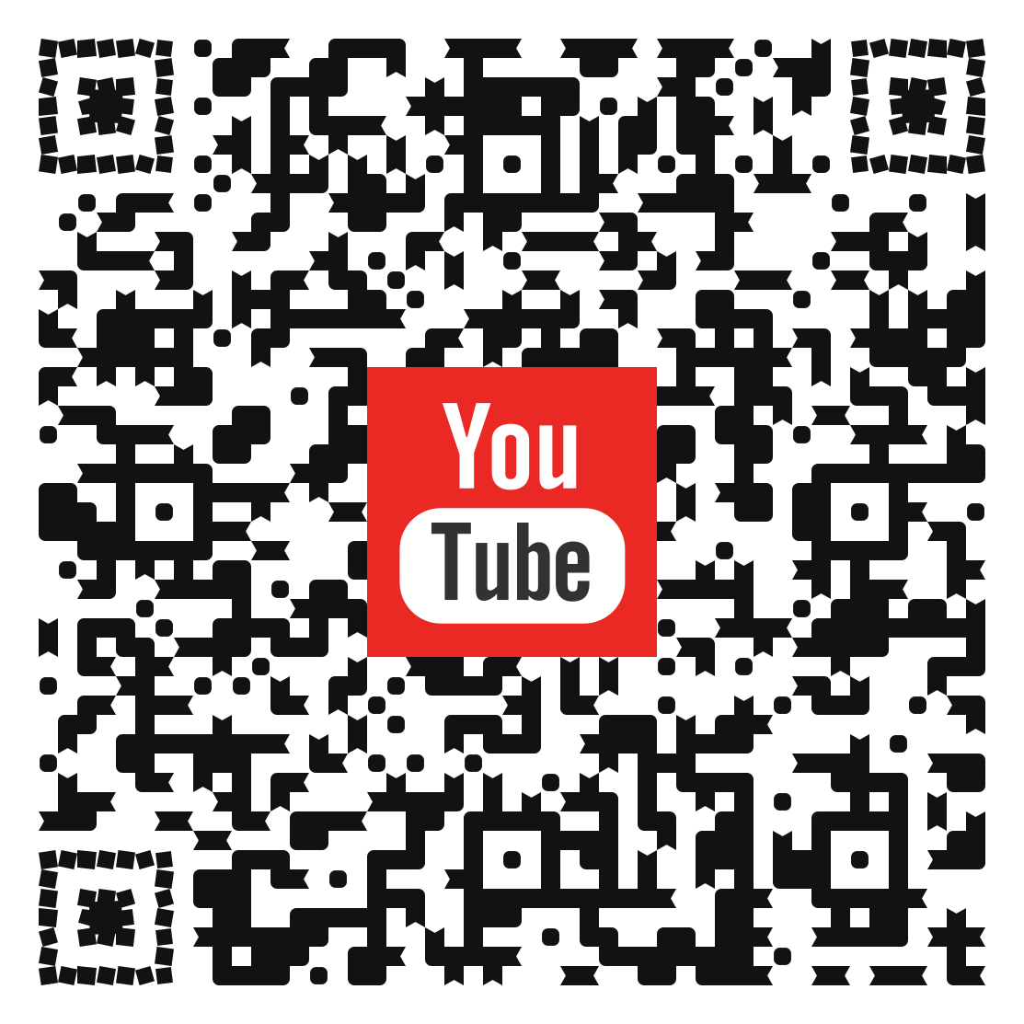Here are two examples and tutorials

Easier example

Tutorial in German

Youtube Channel by cospaces

(english)

More complex example