Notizen zur catilinarischen Verschwörung

|  |
| --- |
|  |
|  |
|  |
|  |
|  |

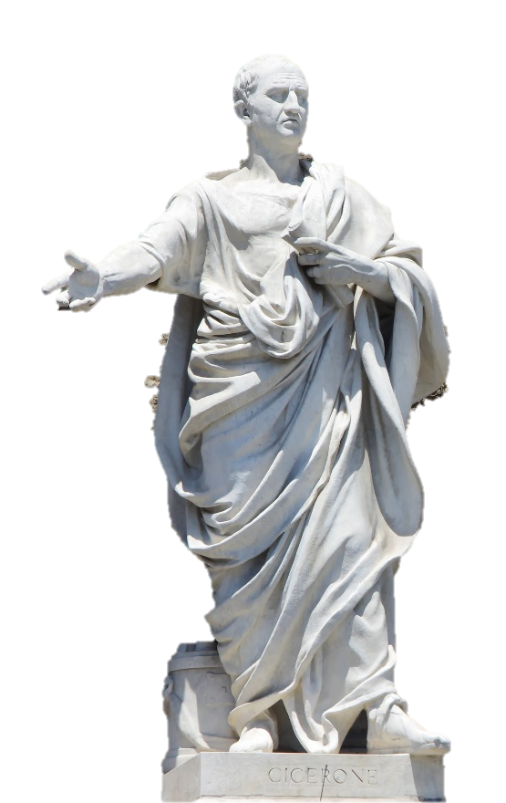

Notizen zu Ciceros Tod

|  |
| --- |
|  |
|  |
|  |
|  |

Notizen zu Ciceros Werken

|  |
| --- |
|  |
|  |
|  |
|  |
|  |

Notizen zur Ciceros sozialem Umfeld

|  |
| --- |
|  |
|  |
|  |
|  |
|  |