Get a camera.
Go to the schoolyard.
Take photos of things.
Upload them to "pixlr.com".
Label the pictures. Start with
"There is…“ for ONE thing or
"There are…“ for SEVERAL things.

Check out your school!
Present your pictures to the
class.

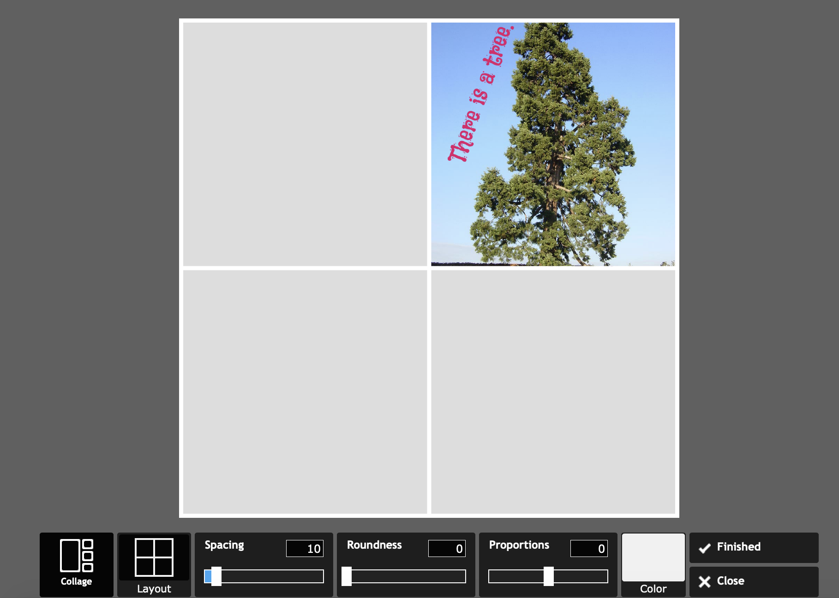
Example
CC BY 1.0, https://commons.wikimedia.org/w/index.php?curid=26110

Dieses Material wurde erstellt von Zolltan Farkas und steht unter der Lizenz CC BY-NC-SA 3.0

