name: ____________________________________

What’s the weather like today?
Checklist
task | done | URL | QR code
Switch on your computer and log in.
Open a browser.
Open a new “LearningApp”. |  | https://learningapps.org/6174387  (Click on the link or copy the URL into your browser. Click on “enter”.) | 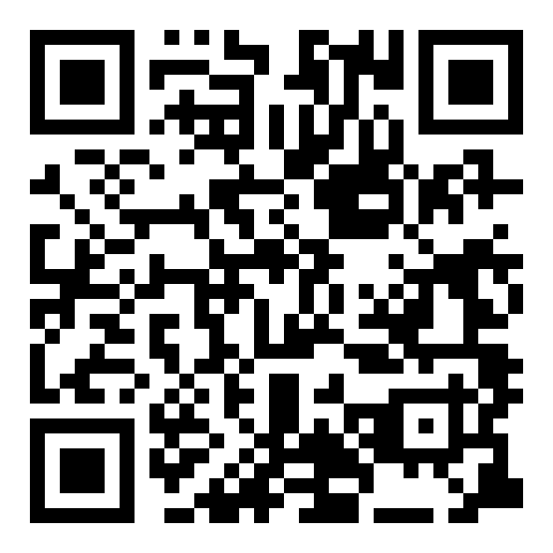
Practice the weather words. Match the words and the pictures.
Open a new “LearningApp”. |  | https://learningapps.org/6342321 | 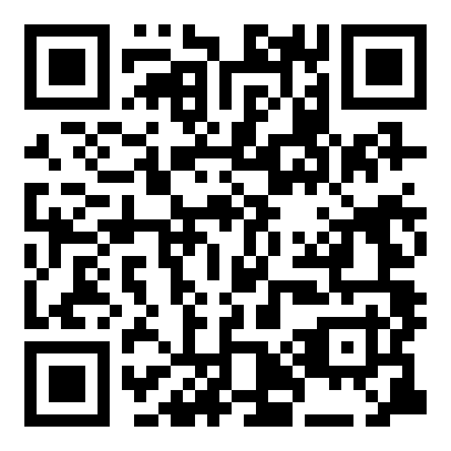
Play memory. Find pairs.
Open a new “LearningApp”. |  | https://learningapps.org/6342347 | 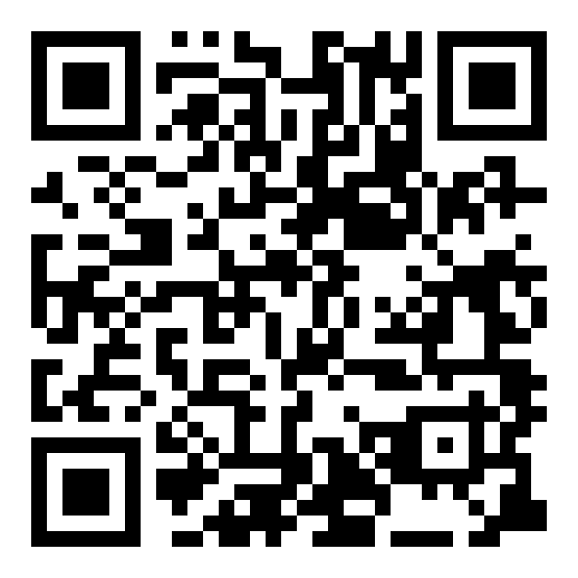
Click on the letters. Find the weather words.
Open a new “LearningApp”. |  | https://learningapps.org/6583058 | 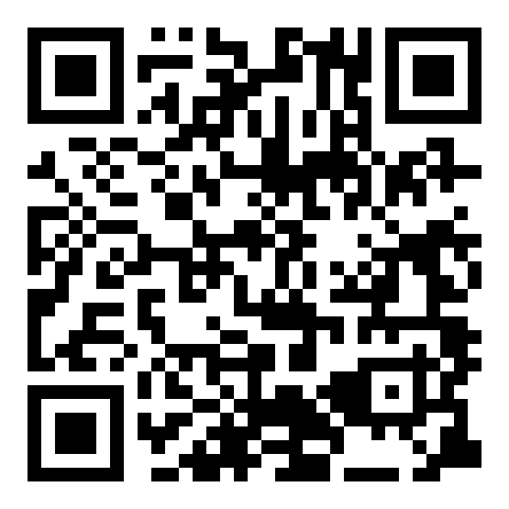
Mark all weather words.
Show me your checklist.

Practice makes perfect!

