Role Description: Richard Stallman, rsm
Richard Stallman is an American programmer and an activist, leading the free software movement. Stallman launched the GNU Project and founded the Free Software Foundation. He studied in Harvard and worked at the MIT Artificial Intelligence Laboratory. He is considered a pioneer in open source software development and the hacker community. He holds fifteen honorary doctorates and professorships.
(cf. https://en.wikipedia.org/wiki/Richard_Stallman, accessed: 4/8/2018)

You are a rigorous Big Data Critic, not a conspiracy theorist. You warn people about the disadvantages of Big Data.
You rarely participate in social media. You are of the opinion that Big Data’s disadvantages will lead to a dystopian world - a world in which the online self will dominate real life interactions and people will solemnly communicate through social media. It worries you deeply that companies centrally accumulate masses of data (intimate, private, public and meta data), giving them the power to potentially use this data against people, putting democracy as a whole in jeopardy. To you Big Data is surveillance.

Richard Stallman
Stallman, Richard. “A radical proposal to keep your personal data safe“, in The Guardian (2018), accessed via https://www.theguardian.com/commentisfree/2018/apr/03/facebook-abusing-data-law-privacy-big-tech-surveillance, 4/7/2018.

by Thesupermat
Richard Stallman - Fête de l'Humanité 2014, CC BY-SA 3.0
(This image contains persons who may have rights that legally restrict certain re-uses of the image without consent.)
(at https://en.wikipedia.org/wiki/Richard_Stallman#/media/File:Richard_Stallman_-_F%C3%AAte_de_l%27Humanit%C3%A9_2014_-_010.jpg)

Tasks
Step 1: Read your role card.

Step 2: Do some research.
- Examine the topic of Big Data from the perspective of a Big Data Critic. You may use the links provided. Do further research, if necessary.
- Collect arguments for and/or against the gathering of Big Data and examples to underline your position.
- In a mind map, collect useful vocabulary and phrases that belong to the world field ‘Big Data’.

During your research you - in your role of a Big Data Critic - will be invited to participate in a Panel Discussion about Big Data at the University of Oxford. Moderator Viktor Mayer-Schönberger (Professor of the Internet Governance and Regulation at Oxford University) and his team will inform you about the exact discussion question.

Big Data - ?

Guests
- Richard Stallman: American programmer and free software activist. He worked at the Artificial Intelligence Laboratory. He founded the GNU Project and is the President of the Free Software Foundation.
- Jan Philipp Albrecht: was a Member of the European Parliament. He was the chief negotiator for the European Parliament concerning the GDPR - EU’s General Data Protection Regulation - coming into effect in May 2018.
- Consumer: enjoys the convenient, ‘free‘ products and services of companies, gathering Big Data and is not concerned about data privacy, since s/he ’does not have anything to hide’.
- Atul Butte: pediatrician and computer scientist from California who analyses already existing, public data to find out which drugs might cure disease.
- Bernard Marr: British author and technology and data expert. He claims that Big Data will affect every business. Those not using Big Data will be left behind.

Step 3: Prepare yourselves for the Panel Discussion.
- Use your notes to prepare yourselves for the Panel Discussion. As a team, …
- think of a good opening statement.
- look at your list of arguments and choose the ones you want to put forward in the Panel Discussion. Support your arguments by giving evidence and/or examples.
- discuss how you can react to possible counter-arguments.
- formulate questions to ask the other guests.
- Select a member of your group to be the first representative in the Panel Discussion.

Step 4: Participate in the Panel Discussion.

Links
title, contents | website | QR code
“World’s Biggest Data Breaches - Selected Losses greater than 30,000 records“ at informationisbeautiful.net  provides an interactive visualization of the world’s biggest data breaches | http://www.informationisbeautiful.net/visualizations/worlds-biggest-data-breaches-hacks/ | 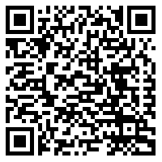
Concordia. “The Power of Big Data and Psychographics“, youtube.com, 9/27/2916.  Talk by Alexander Nix (CEO of Cambridge Analytica) about audience targeting, data modeling, psychographic profiling at the 2016 Concordia Annual Summit in New York. | https://www.youtube.com/watch?v=n8Dd5aVXLCc | 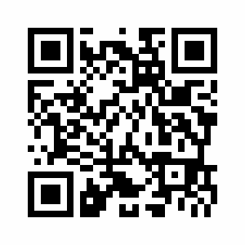
Botsman, Rachel. “Big data meets Big Brother as China moves to rate its citizens“, at wired.co.uk, 10/21/2017.  Complex article about China’s Social Credit System, rating the trustworthiness of its citizens - to be launched in 2020 | http://www.wired.co.uk/article/chinese-government-social-credit-score-privacy-invasion | 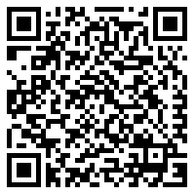
Stallman, Richard. “A radical proposal to keep your personal data safe“, theguardian.com, 4/3/2018.  Comprehensive article about the need to not collect data at all | https://www.theguardian.com/commentisfree/2018/apr/03/facebook-abusing-data-law-privacy-big-tech-surveillance | 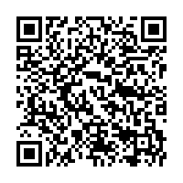

Possible further research
- Cambridge Analytica Scandal, 2017
- Fake News and echo chambers
- whistle blowers: Edward Snowden, Chelsea Manning, Chris Wylie

Role Description: Jan Philipp Albrecht
Jan Philipp Albrecht is a politician and member of the Green Party (Bündnis 90/Die Grünen). From 2009-2018 he was a Member of the European Parliament. His focus has been civil liberties, digital policy and data protection. As the chief negotiator for the European Parliament, he has played an essential role in the legislative process concerning the EU’s General Data Protection Regulation (GDPR).
(cf. https://www.janalbrecht.eu/biography/, accessed: 4/8/2018)

You are a Big Data Sceptic. You understand the advantages of Big Data, but you believe the gathering of data has gone too far. You see the need to restrict the power companies gain through the accumulation of Big Data as well as to protect people from their own naiveté. That is why you are of the opinion that informational self-determination is essential: your data belongs to you only - not companies. You support open source projects.

Jan Philipp Albrecht about the GDPR (General Data Protection Regulation, coming into effect: May 25th, 2018), European Parliament:
(Democracy - Im Rausch der Daten. Directed by David Bernet. 2016; Germany: farbfilm home entertainment, 2016. Film. 49:53-50:39.)
“We are here, of course today, to take an important next step in formulating data protection in Europe; at the same time strengthening trust and innovation in the European digital market. […] First of all, data protection is a fundamental right. If you want my data, ask me for consent. Because everyone wants to be asked at least. And the companies have the duty to explain in a simple form what they do with our data.“

by Mathias Schindler, CC BY-SA 3.0
Netzregeln10-Jan-Philipp-Albrecht.jpg
(at https://en.wikipedia.org/wiki/Jan_Philipp_Albrecht#/media/File:Netzregeln10-Jan-Philipp-Albrecht.jpg)

Tasks
Step 1: Read your role card.

Step 2: Do some research.
- Examine the topic of Big Data from the perspective of a Big Data Sceptic. You may use the links provided. Do further research, if necessary.
- Collect arguments for and/or against the gathering of Big Data and examples to underline your position.
- In a mind map, collect useful vocabulary and phrases that belong to the world field ‘Big Data’.

During your research you - in your role of a Big Data Sceptic - will be invited to participate in a Panel Discussion about Big Data at the University of Oxford. Moderator Viktor Mayer-Schönberger (Professor of the Internet Governance and Regulation at Oxford University) and his team will inform you about the exact discussion question.

Big Data - ?

Guests
- Richard Stallman: American programmer and free software activist. He worked at the Artificial Intelligence Laboratory. He founded the GNU Project and is the President of the Free Software Foundation.
- Jan Philipp Albrecht: was a Member of the European Parliament. He was the chief negotiator for the European Parliament concerning the GDPR - EU’s General Data Protection Regulation - coming into effect in May 2018.
- Consumer: enjoys the convenient, ‘free‘ products and services of companies, gathering Big Data and is not concerned about data privacy, since s/he ’does not have anything to hide’.
- Atul Butte: pediatrician and computer scientist from California who analyses already existing, public data to find out which drugs might cure disease.
- Bernard Marr: British author and technology and data expert. He claims that Big Data will affect every business. Those not using Big Data will be left behind.

Step 3: Prepare yourselves for the Panel Discussion.
- Use your notes to prepare yourselves for the Panel Discussion. As a team, …
- think of a good opening statement.
- look at your list of arguments and choose the ones you want to put forward in the Panel Discussion. Support your arguments by giving evidence and/or examples.
- discuss how you can react to possible counter-arguments.
- formulate questions to ask the other guests.
- Select a member of your group to be the first representative in the Panel Discussion.

Step 4: Participate in the Panel Discussion.
Links
title, contents | website | QR code
Albrecht, Jan Philipp, MEP: “My data, my choice // What you need to know about the EU's new privacy law“, youtube.com, 12/21/2015.  Video about the GDPR (General Data Protection Regulation) | https://www.youtube.com/watch?v=PVaVIOJniSQ | 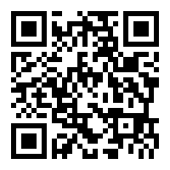
Rowe, Mike. “Expert Comment: AI profiling: the social and moral hazards of ‘predictive’ policing“, northumbria.ac.uk, 3/9/2018.  Comprehensive comment about the biases of AI concerning certain groups in “predictive policing” | https://www.northumbria.ac.uk/about-us/news-events/news/2018/03/ai-profiling-the-social-and-moral-hazards-of-predictive-policing/ | 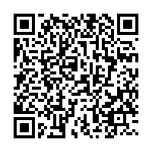
Yates, Helen. “Personal data may penalise ‘uninsurables’“, raconteur.net, 6/14/2017.  Article about possible disadvantages of personal data-driven insurance product | https://www.raconteur.net/business/personal-data-may-penalise-uninsurables | 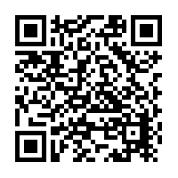
Walsh, Bryan. “Google’s Flu Project Shows the Failings of Big Data“, time.com, 3/13/2014.  Comprehensive article about the failure Google’s Flu Project, which attempted to predict flu patterns by correlating Google searches for ‘flu’ and the geographical information of the searcher | http://time.com/23782/google-flu-trends-big-data-problems/ | 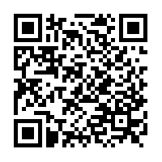
Reitman, Rainey: “Who Has Your Back. Government Data Requests 2017“, eff.org, 7/10/2017.  Complex study with comprehensible visualizations about data protection and transparency concerning companies | https://www.eff.org/who-has-your-back-2017 | 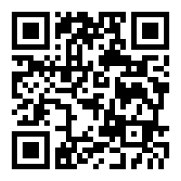
https://alternativeto.net  Commercial website, providing alternatives to proprietary software | https://alternativeto.net | 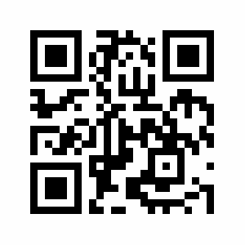
prism-break.org  Open source website, providing alternatives to proprietary software | https://prism-break.org/en/all/ | 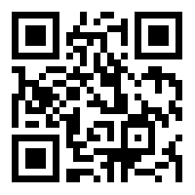

Possible further research
- General Data Protection Regulation (https://www.eugdpr.org/the-regulation.html)
- cryptography
  - against the gathering of meta data: Tor, Proxy, VPN

Role Description: Consumer
You are a seemingly naive Big Data Optimist. You focus on the advantages of social media and Big Data.
You are an educated young adult, aspiring to making the world a better place. The use of several apps and wearables is natural to you; you enjoy their ‘free’ content and convenient services. You do not seem to care about data privacy, since ’you don’t have anything to hide’. You are glad that through social media everybody can create, share, rate, and connect - everybody has a voice. You believe that the analysis of Big Data helps people to become the best version of themselves.

Tasks
Step 1: Read your role card.

Step 2: Do some research.
- Examine the topic of Big Data from the perspective of a Big Data Optimist. You may use the links provided. Do further research, if necessary.
- Collect arguments for and/or against the gathering of Big Data and examples to underline your position.
- In a mind map, collect useful vocabulary and phrases that belong to the world field ‘Big Data’.

During your research you - in your role of a Big Data Optimist - will be invited to participate in a Panel Discussion about Big Data at the University of Oxford. Moderator Viktor Mayer-Schönberger (Professor of the Internet Governance and Regulation at Oxford University) and his team will inform you about the exact discussion question.

Big Data - ?

Guests
- Richard Stallman: American programmer and free software activist. He worked at the Artificial Intelligence Laboratory. He founded the GNU Project and is the President of the Free Software Foundation.
- Jan Philipp Albrecht: was a Member of the European Parliament. He was the chief negotiator for the European Parliament concerning the GDPR - EU’s General Data Protection Regulation - coming into effect in May 2018.
- Consumer: enjoys the convenient, ‘free‘ products and services of companies, gathering Big Data and is not concerned about data privacy, since s/he ’does not have anything to hide’.
- Atul Butte: pediatrician and computer scientist from California who analyses already existing, public data to find out which drugs might cure disease.
- Bernard Marr: British author and technology and data expert. He claims that Big Data will affect every business. Those not using Big Data will be left behind.

Step 3: Prepare yourselves for the Panel Discussion.
- Use your notes to prepare yourselves for the Panel Discussion. As a team, …
- think of a good opening statement.
- look at your list of arguments and choose the ones you want to put forward in the Panel Discussion. Support your arguments by giving evidence and/or examples.
- discuss how you can react to possible counter-arguments.
- formulate questions to ask the other guests.
- Select a member of your group to be the first representative in the Panel Discussion.

Step 4: Participate in the Panel Discussion.

Links
title, contents | website | QR code
Zuckerberg, Mark. “Building Global Community“, facebook.com, 2/16/2017.  Zuckerberg’s open letter to the Facebook community, explaining how Facebook seeks to make a positive impact on communities | https://www.facebook.com/notes/mark-zuckerberg/building-global-community/10154544292806634/ | 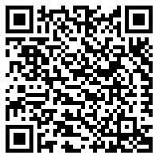
Marr, Bernhard. “Want To Use Big Data? Why Not Start Via Google, Facebook, Amazon, (Etc.)“, forbes.com, 8/14/2017.  Comprehensive article about the upsides of Big Data for consumers | https://www.forbes.com/sites/bernardmarr/2017/08/14/want-to-use-big-data-why-not-start-via-google-facebook-amazon-etc/#103d70c73d5d | 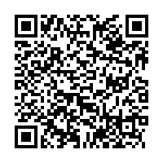
Deng, Olivia. “Data Analytics -  March for Our Lives was Born on Social Media“, crimsonhexagon.com, accessed: 4/8/2018.  Analysis of the relation between social movement ‚March For Our Lives‘ and social media | https://www.crimsonhexagon.com/blog/march-for-our-lives-was-born-on-social-media/ | 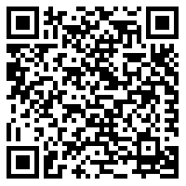
NBC News. “Why Netflix’s Algorithm Is So Binge-Worthy | Mach | NBC News“, youtube.com, 4/25/2017  3-minute video, explaining Netflix’ individual recommendations through algorithms - for customers’ convenience | https://www.youtube.com/watch?v=nq2QtatuF7U | 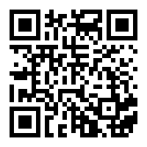
Ben-Shahar, Omri. “Opinion: Privacy is the New Money, Thanks to Big Data“, forbes.com, 4/1/2016.  Opinion piece by a Chicago Law Professor about people’s indifference about Big Data collection and the ‘free' use of online services | https://www.forbes.com/sites/omribenshahar/2016/04/01/privacy-is-the-new-money-thanks-to-big-data/#578027783fa2 | 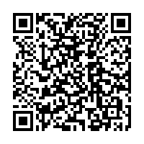

Role Description: Atul Butte
Dr. Atul Butte is a pediatrician and computer scientist living in California with his wife and daughter. He studied Computer Science at Brown University, worked as a software engineer at Apple and Microsoft, trained in Pediatrics at Children’s Hospital Boston and received his Ph.D. in Health Sciences and Technology from Harvard Medical School and MIT. Since 2015 he is heading the Institute for Computational Health Sciences at the University of California.
(cf. https://en.wikipedia.org/wiki/Atul_Butte, accessed: 4/8/2018)

You are a Big Data Advocate. By analyzing already existing data, your team tries to find out which drugs might cure disease and has already shown that a drug originally approved to kill parasitic worms might combat liver cancer. Thus, you are firmly convinced that Big Data analytics provide valuable insights into medicine and health. However, you also know that issues of privacy still need to be addressed. Who should be able to have access to the data and how do we protect patients from discrimination?

Atul Butte about the potential for big data in medical science:
(Goldman, Bruce. “King of the Mountain. Digging Data for a Healthier World”, 2012, accessed via http://sm.stanford.edu/archive/stanmed/2012summer/article3.html 4/8/2018)
“Hiding within those mounds of data is knowledge that could change the life of a patient, or change the world. If I don’t analyze those data and show others how to do it, too, I fear that no one will.”

by CTSI at UCSF
Informed Health 2015, CC BY-NC 2.0
(at https://www.flickr.com/photos/ctsiatucsf/15832350303/, accessed 8/4/2018)

Tasks
Step 1: Read your role card.

Step 2: Do some research.
- Examine the topic of Big Data from the perspective of a Big Data Advocate. You may use the links provided. Do further research, if necessary.
- Collect arguments for and/or against the gathering of Big Data and examples to underline your position.
- In a mind map, collect useful vocabulary and phrases that belong to the world field ‘Big Data’.

During your research you - in your role of a Big Data Advocate - will be invited to participate in a Panel Discussion about Big Data at the University of Oxford. Moderator Viktor Mayer-Schönberger (Professor of the Internet Governance and Regulation at Oxford University) and his team will inform you about the exact discussion question.

Big Data - ?

Guests
- Richard Stallman: American programmer and free software activist. He worked at the Artificial Intelligence Laboratory. He founded the GNU Project and is the President of the Free Software Foundation.
- Jan Philipp Albrecht: was a Member of the European Parliament. He was the chief negotiator for the European Parliament concerning the GDPR - EU’s General Data Protection Regulation - coming into effect in May 2018.
- Consumer: enjoys the convenient, ‘free‘ products and services of companies, gathering Big Data and is not concerned about data privacy, since s/he ’does not have anything to hide’.
- Atul Butte: pediatrician and computer scientist from California who analyses already existing, public data to find out which drugs might cure disease.
- Bernard Marr: British author and technology and data expert. He claims that Big Data will affect every business. Those not using Big Data will be left behind.

Step 3: Prepare yourselves for the Panel Discussion.
- Use your notes to prepare yourselves for the Panel Discussion. As a team, …
- think of a good opening statement.
- look at your list of arguments and choose the ones you want to put forward in the Panel Discussion. Support your arguments by giving evidence and/or examples.
- discuss how you can react to possible counter-arguments.
- formulate questions to ask the other guests.
- Select a member of your group to be the first representative in the Panel Discussion.

Step 4: Participate in the Panel Discussion.

Links
title, content | website | QR code
BBC: “Will 'big data' prevent disease?,” bbc.com, 11/18/2014.  A short interview with Linda Avey, genetics entrepreneur, on the question of whether Big Data can cure disease. | http://www.bbc.com/future/story/20121212-will-big-data-cure-disease | 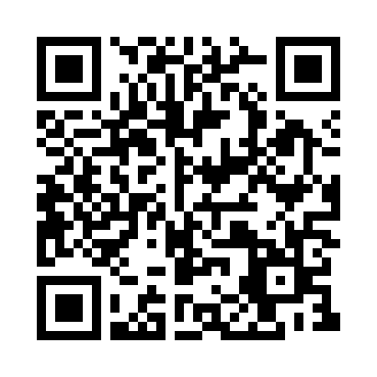
Madan, Amol: “Your Smartphone, Your Therapist?”, huffingtonpost.com, 1/23/2016.  An article about Ginger.io, a smartphone app developed by data scientists from MIT that predicts when patients with mental illnesses are symptomatic and offers emotional support and care. | https://www.huffingtonpost.com/anmol-madan/your-smartphone-your-therapist_b_9054156.html | 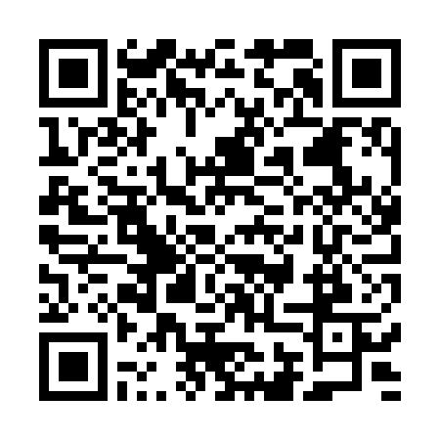
Cha, Ariana Eunjung: “Health and Data: Can Digital Fitness Monitors Revolutionise Our Lives?”, theduardian.com, 5/19/2015.  An article about the benefits and possible dangers of health-tracking technology (including a fantastic illustration of health-monitoring devices). | https://www.theguardian.com/society/2015/may/19/digital-fitness-technology-data-heath-medicine | 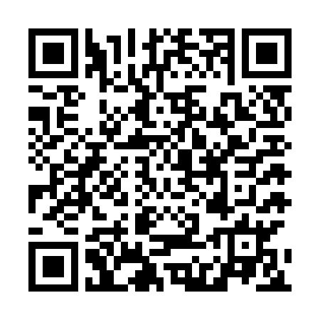
Altman, Russ: “What really happens when you mix medications?”, tedmed.com, 2015.  Russ Altman, professor of bioengineering, genetics, medicine, and biomedical data science, explains how Big Data could help to understand drug interactions. | https://www.tedmed.com/talks/show?id=529433 | 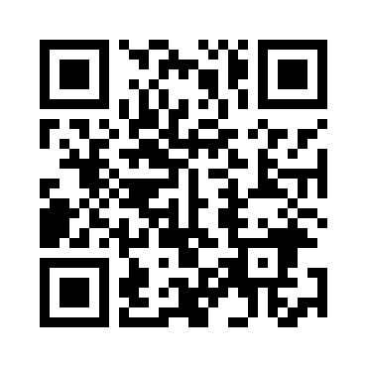

Possible further research
- predictive healthcare
- wearable technology

Role Description: Bernard Marr
Bernard Marr is a technology and data expert. He has written 15 books, including the bestseller Data Strategy: How to Profit From a World of Big Data (2017), and writes weekly columns for Forbes, Huffington Post and LinkedIn. When it comes to data in business, he is one of the most highly respected advisors. Together with his wife and their three children he lives in the north of London, England.
(cf. https://www.bernardmarr.com/default.asp?contentID=645, accessed: 4/8/2018)

You are a Big Data Expert. You argue that all companies, whether big or small, need to take Big Data seriously as it offers considerable benefits to both consumers and companies. Big Data Analytics help companies to make more informed business decisions, improve their marketing strategy or make better pricing decisions. In short, Big Data means big profit. In return, customers or users get free apps or products that are tailor-made to their needs. Thus, it is no surprise that they happily share their personal data.

Bernard Marr
Marr, Bernard. Data Strategy: How to Profit from a World of Big Data, Analytics and the Internet of Things. London: Kogan Page. 2017. p. 16.

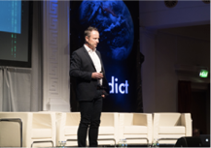
“It’s clear that data is becoming a key business asset, central to the success of every company. As the world becomes smarter and smarter, data becomes the key to competitive advantage, meaning a company’s ability to compete will increasingly be driven by how well it can leverage data, apply analytics and implement new technologies. […] In business, information is power, and big data is providing information we couldn’t have dreamed of collecting or analyzing just a few short years ago. Companies that don’t evolve and embrace the data revolution will be left behind.”

by William Murphy
Big Data in Practice by Bernard Marr [Predict at the RDS October 2016]-121668, 2016, CC BY-SA 2.0
(at https://bit.ly/2IAKntB (shortened URL), accessed 8/4/2018)

Tasks
Step 1: Read your role card.

Step 2: Do some research.
- Examine the topic of Big Data from the perspective of a Big Data Expert. You may use the links provided. Do further research, if necessary.
- Collect arguments for and/or against the gathering of Big Data and examples to underline your position.
- In a mind map, collect useful vocabulary and phrases that belong to the world field ‘Big Data’.

During your research you - in your role of a Big Data Expert - will be invited to participate in a Panel Discussion about Big Data at the University of Oxford. Moderator Viktor Mayer-Schönberger (Professor of the Internet Governance and Regulation at Oxford University) and his team will inform you about the exact discussion question.

Big Data - ?

Guests
- Richard Stallman: American programmer and free software activist. He worked at the Artificial Intelligence Laboratory. He founded the GNU Project and is the President of the Free Software Foundation.
- Jan Philipp Albrecht: was a Member of the European Parliament. He was the chief negotiator for the European Parliament concerning the GDPR - EU’s General Data Protection Regulation - coming into effect in May 2018.
- Consumer: enjoys the convenient, ‘free‘ products and services of companies, gathering Big Data and is not concerned about data privacy, since s/he ’does not have anything to hide’.
- Atul Butte: pediatrician and computer scientist from California who analyses already existing, public data to find out which drugs might cure disease.
- Bernard Marr: British author and technology and data expert. He claims that Big Data will affect every business. Those not using Big Data will be left behind.

Step 3: Prepare yourselves for the Panel Discussion.
- Use your notes to prepare yourselves for the Panel Discussion. As a team, …
- think of a good opening statement.
- look at your list of arguments and choose the ones you want to put forward in the Panel Discussion. Support your arguments by giving evidence and/or examples.
- discuss how you can react to possible counter-arguments.
- formulate questions to ask the other guests.
- Select a member of your group to be the first representative in the Panel Discussion.

Step 4: Participate in the Panel Discussion.
Links
title, contents | website | QR code
Marr, Bernard: “4 Ways Big Data Will Change Every Business”, forbes.com, 9/8/2015.  Bernard Marr points out how data is revolutionizing the world of business. | https://www.forbes.com/sites/bernardmarr/2015/09/08/4-ways-big-data-will-change-every-business/#4dc622bb2729 | 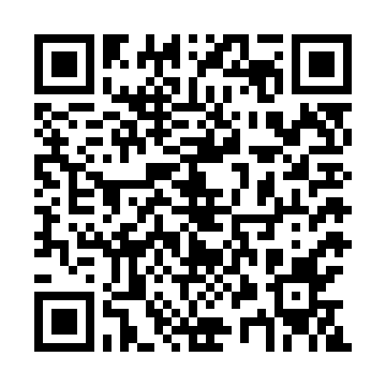
IBM Analytics: “Big Data, Big opportunities for Marketing”, youtube.com, 7/18/2013.  A promotional video from IBM about how Big Data analytics can be used to improve marketing. | https://www.youtube.com/watch?v=xJfP_o_fANA | 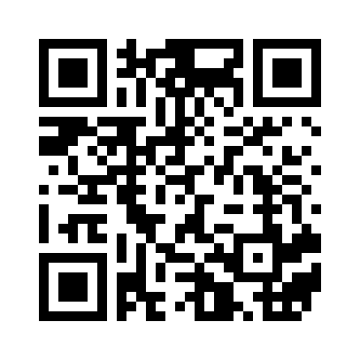
Big Think: “How Amazon’s Algorithm Gets You to Spend Money“, youtube.com, 8/19/2015.  Jerry Kaplan, author and entrepreneur, explains how websites like Amazon study consumer behaviour to maximize their profits. | https://www.youtube.com/watch?v=GSAz0vVfVmo | 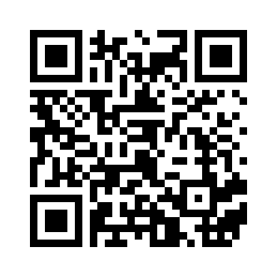
Sinha, Gunjan: “The Power of Intelligence”, huffingtonpost.com, 12/21/2016.  An insightful article summarizing several benefits of big data not only for companies. | https://www.huffingtonpost.com/gunjan-sinha/the-power-of-intelligence_b_13752044.html | 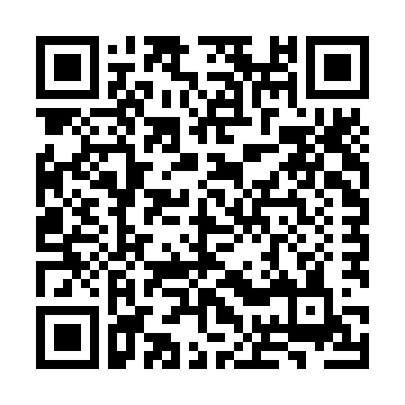
Marr, Bernard: “The Amazing Ways Instagram Uses Big Data and Artificial Intelligence”, forbes.com, 3/16/2018.  Helpful insights into how Instagram uses big data to enhance its platform for both users and advertisers. | https://www.forbes.com/sites/bernardmarr/2018/03/16/the-amazing-ways-instagram-uses-big-data-and-artificial-intelligence/#5d5f73db5ca6 | 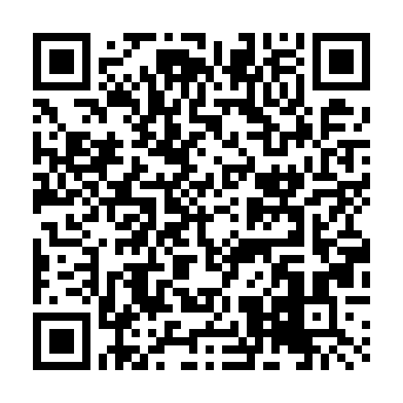
Post, Rachael: “Ford and Nike use big data to make smarter sustainable design”, guardian.com, 2/18/2014.  An article about two companies rethinking products’ sustainability using big data. | https://www.theguardian.com/sustainable-business/ford-nike-big-data-smart-sustainable-design | 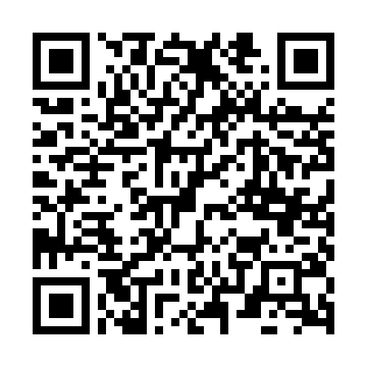
Possible further research: articles by Bernard Marr (forbes.com); companies (successfully) using big data: Facebook, Amazon, Google, Netflix, Spotify, Apple, Microsoft, Uber…

Role Description: Viktor Mayer-Schönberger
Viktor Mayer-Schönberger is the Professor of Internet Governance and Regulation at Oxford University. He studied in Salzburg, Harvard and London and founded Ikarus Software, a company focusing on data security. He has published several books, including the international bestseller Big Data: A Revolution That Will Transform How We Live, Work, and Think (co-authored with Kenneth Cukier, 2013) and is a frequent public speaker and expert for big data.
(cf. https://www.oii.ox.ac.uk/people/viktor-ms/, accessed: 4/8/2018)

For your current lecture series you have invited experts from practice, politics and science to discuss the benefits and dangers of Big Data analytics. Your task is to moderate the Panel Discussion. Your guests are:
- Richard Stallman: American programmer and free software activist. He worked at the Artificial Intelligence Laboratory. He founded the GNU Project and is the President of the Free Software Foundation.
- Jan Philipp Albrecht: was a Member of the European Parliament. He was the chief negotiator for the European Parliament concerning the GDPR - EU’s General Data Protection Regulation - coming into effect in May 2018.
- Consumer: enjoys the convenient, ‘free‘ products and services of companies, gathering Big Data and is not concerned about data privacy, since s/he ’does not have anything to hide’.
- Atul Butte: pediatrician and computer scientist from California who analyses already existing, public data to find out which drugs might cure disease.
- Bernard Marr: British author and technology and data expert. He claims that Big Data will affect every business. Those not using Big Data will be left behind.

Viktor Mayer-Schönberg
(Cukier, Kenneth and Viktor Mayer-Schönberger. Big Data: The Essential Guide to Work, Life and Learning in the Age of Insight. London: John Murray. 2013.)
“In fact, with the right mindset, data can be cleverly reused to become a fountain of innovation and new services. The data can reveal secrets to those with the humility, the willingness, and the tools to listen.”

by re:publica/Gregor Fischer
Viktor Mayer-Schönberger - re:publica 2014, Tag 2, 5/7/2014, CC BY-SA 2.0
(at https://bit.ly/2GMSZN6 (shortened URL), accessed 8/4/2018)

Jay Walker about Big Data:
(The Human Face of Big Data. Directed by Sandy Smolan. 2014. https://www.youtube.com/watch?v=m9D-v6r3NJQ, 03:23-03:35, accessed 8/4/2018) "Every powerful tool has a dark side. Every last one. Anything that is going to change the world by definition has to be able to change it for the worse as much as for the better. It doesn’t work one way without the other.”
Tasks
Step 1: Read your role card.

Step 2: Do some research.
- Examine the topic of Big Data from the perspective of a neutral moderator. You may use the links provided. Do further research, if necessary.
- In a mind map, collect useful vocabulary and phrases that belong to the world field ‘Big Data’.
- During your research you should come up with a controversial question for the Panel Discussion. Invite your guests and inform them about the exact topic:

Big Data - ?

As a team of moderators you can also inform yourselves about the other groups without disturbing them. You might want to listen and watch or ask a question.

Step 3: Prepare yourselves for the Panel Discussion.
- Use your notes to prepare yourselves for the Panel Discussion. As a team, …
- prepare an introduction to the topic that arouses the interest of the audience. Your introduction should also include a definition of the term Big Data.
- formulate questions to ask your guests and the audience during the Panel Discussion.
- think of impulses to activate the members of the panel in case the discussion slows down.
- Select a member of your group to be the first representative in the Panel Discussion.

Step 4: Participate in the Panel Discussion. Make sure to stay neutral and to keep the conversation going.

Links
title, contents | website | QR code
Marr, Bernard: “What is Big Data? A Super Simple Explanation For Everyone”, bernardmarr.com.  Bernard Marr on Big Data, how it works and how it is being used. | https://www.bernardmarr.com/default.asp?contentID=766
Cukier, Kenneth: “Big Data is Better Data”, ted.com, 2014.  Kenneth Cukier explains why the big in the term Big Data is important and looks at the benefits and dark sides of Big Data. | https://www.ted.com/talks/kenneth_cukier_big_data_is_better_data/discussion?rss | 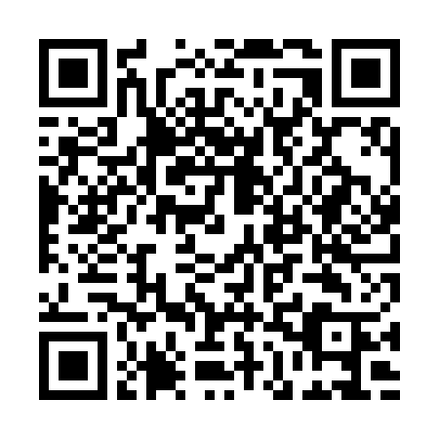
THNKR: “The Dangers of Big Data”, youtube.com, 4/16/2013.  Rick Smolan discusses the power of big data as well as issues of privacy and discrimination. | https://www.youtube.com/watch?v=y8yMlMBCQiQ | 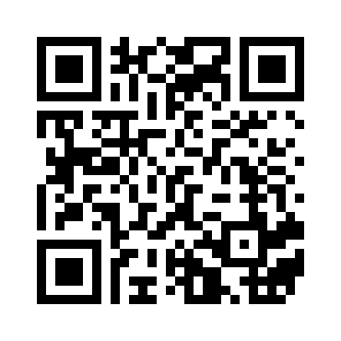
Marr, Bernard: “How is Big Data used in practice? 10 use cases everyone must read”, bernardmarr.com.  A list of 10 major areas in which big data is used. | https://www.bernardmarr.com/default.asp?contentID=1076 | 