Role Description: Fictional Character in The Circle: Mercer Medeiros
Mercer Medeiros resists The Circle and everything it stands for: its monopoly, its lack of privacy, its intransparency and its unethical use of personal data.

You are a rigorous Big Data Critic, not a conspiracy theorist. You warn people about the disadvantages of Big Data.
You rarely participate in social media. You are of the opinion that Big Data’s disadvantages will lead to a dystopian world - a world in which the online self will dominate real life interactions and people will solemnly communicate through social media. It worries you deeply that companies centrally accumulate masses of data (intimate, private, public and meta data) giving them the power to potentially use this data against people, putting democracy as a whole in jeopardy. To you Big Data is surveillance.

Tasks
Step 1: Read your role card.

Step 2: Do some research.
- Examine the topic of Big Data from the perspective of a Big Data Critic. You may use the links provided. Do further research, if necessary.
- Collect arguments for and/or against the gathering of Big Data and examples to underline your position.
- In a mind map, collect useful vocabulary and phrases that belong to the world field ‘Big Data’.

During your research you - in your role of a Big Data Critic - will be invited to participate in a Panel Discussion about Big Data at the University of Oxford. Moderator Viktor Mayer-Schönberger (Professor of the Internet Governance and Regulation at Oxford University) and his team will inform you about the exact discussion question.

Big Data - ?

Guests
- Mercer Medeiros: resists the Circle and its unethical privacy practices.
- Ty Gospodinov: co-founder of the Circle, seeing the danger of the lack of transparency and the accumulation of Big Data.
- Mae Holland: has gone fully transparent, sharing every moment of her life with millions of followers. She values the community of social media.
- Dr. Villalobos: a physician at the Circle’s clinic arguing that Big Data helps to improve healthcare and cure disease.
- Eamon Bailey: co-founder of the Circle, thinking that every company should harness Big Data to better understand their customers and make more profit.

Step 3: Prepare yourselves for the Panel Discussion.
- Use your notes to prepare yourselves for the Panel Discussion. As a team, …
- think of a good opening statement.
- look at your list of arguments and choose the ones you want to put forward in the Panel Discussion. Support your arguments by giving evidence and/or examples.
- discuss how you can react to possible counter-arguments.
- formulate questions to ask the other guests.
- Select a member of your group to be the first representative in the Panel Discussion.

Step 4: Participate in the Panel Discussion.

Links
title, contents | website | QR code
“World’s Biggest Data Breaches - Selected Losses greater than 30,000 records“ at informationisbeautiful.net  provides an interactive visualization of the world’s biggest data breaches | http://www.informationisbeautiful.net/visualizations/worlds-biggest-data-breaches-hacks/ | 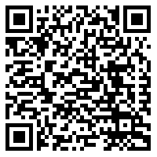
Concordia. “The Power of Big Data and Psychographics“, youtube.com, 9/27/2916.  Talk by Alexander Nix (CEO of Cambridge Analytica) about audience targeting, data modeling, psychographic profiling at the 2016 Concordia Annual Summit in New York. | https://www.youtube.com/watch?v=n8Dd5aVXLCc | 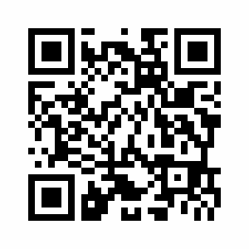
Botsman, Rachel. “Big data meets Big Brother as China moves to rate its citizens“, at wired.co.uk, 10/21/2017.  Complex article about China’s Social Credit System, rating the trustworthiness of its citizens - to be launched in 2020 | http://www.wired.co.uk/article/chinese-government-social-credit-score-privacy-invasion | 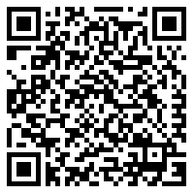
Stallman, Richard. “A radical proposal to keep your personal data safe“, theguardian.com, 4/3/2018.  Comprehensive article about the need to not collect data at all | https://www.theguardian.com/commentisfree/2018/apr/03/facebook-abusing-data-law-privacy-big-tech-surveillance

Possible further research
- Cambridge Analytica Scandal, 2017
- Fake News and echo chambers
- whistle blowers: Edward Snowden, Chelsea Manning, Chris Wylie

Role Description: Fictional Character in The Circle, Tyler Gospodinov
Tyler Gospodinov is one of the founders of the Circle. He is an introverted developer and has created TruYou, a “Unified Operating System“, attempting to optimize internet use. Throughout the novel Ty’s attitude changes.
Now you are a Big Data Sceptic. You understand the advantages of Big Data, but you believe the gathering of data has gone too far. You see the need to restrict the power companies gain through the accumulation of Big Data as well as to protect people from their own naiveté. That is why you are of the opinion that informational self-determination is essential: your data belongs to you only - not companies. You support open source projects.

Tasks
Step 1: Read your role card.

Step 2: Do some research.
- Examine the topic of Big Data from the perspective of a Big Data Sceptic. You may use the links provided. Do further research, if necessary.
- Collect arguments for and/or against the gathering of Big Data and examples to underline your position.
- In a mind map, collect useful vocabulary and phrases that belong to the world field ‘Big Data’.

During your research you - in your role of a Big Data Sceptic - will be invited to participate in a Panel Discussion about Big Data at the University of Oxford. Moderator Viktor Mayer-Schönberger (Professor of the Internet Governance and Regulation at Oxford University) and his team will inform you about the exact discussion question.

Big Data - ?

Guests
- Mercer Medeiros: resists the Circle and its unethical privacy practices.
- Ty Gospodinov: co-founder of the Circle, seeing the danger of the lack of transparency and the accumulation of Big Data.
- Mae Holland: has gone fully transparent, sharing every moment of her life with millions of followers. She values the community of social media.
- Dr. Villalobos: a physician at the Circle’s clinic arguing that Big Data helps to improve healthcare and cure disease.
- Eamon Bailey: co-founder of the Circle, thinking that every company should harness Big Data to better understand their customers and make more profit.

Step 3: Prepare yourselves for the Panel Discussion.
- Use your notes to prepare yourselves for the Panel Discussion. As a team, …
- think of a good opening statement.
- look at your list of arguments and choose the ones you want to put forward in the Panel Discussion. Support your arguments by giving evidence and/or examples.
- discuss how you can react to possible counter-arguments.
- formulate questions to ask the other guests.
- Select a member of your group to be the first representative in the Panel Discussion.

Step 4: Participate in the Panel Discussion.

_____
Step 5: After the discussion: Communicate the tools which can be used to protect personal data to your classmates.

Links
title, contents | website | QR code
Albrecht, Jan Philipp, MEP: “My data, my choice // What you need to know about the EU's new privacy law“, youtube.com, 12/21/2015.  Video about the GDPR (General Data Protection Regulation) | https://www.youtube.com/watch?v=PVaVIOJniSQ
Rowe, Mike. “Expert Comment: AI profiling: the social and moral hazards of ‘predictive’ policing“, northumbria.ac.uk, 3/9/2018.  Comprehensive comment about the biases of AI concerning certain groups in “predictive policing” | https://www.northumbria.ac.uk/about-us/news-events/news/2018/03/ai-profiling-the-social-and-moral-hazards-of-predictive-policing/
Yates, Helen. “Personal data may penalise ‘uninsurables’“, raconteur.net, 6/14/2017.  Article about possible disadvantages of personal data-driven insurance product | https://www.raconteur.net/business/personal-data-may-penalise-uninsurables | 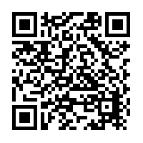
Walsh, Bryan. “Google’s Flu Project Shows the Failings of Big Data“, time.com, 3/13/2014.  Comprehensive article about the failure Google’s Flu Project, which attempted to predict flu patterns by correlating Google searches for ‘flu’ and the geographical information of the searcher | http://time.com/23782/google-flu-trends-big-data-problems/ | 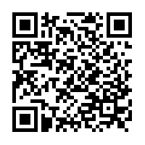
Reitman, Rainey: “Who Has Your Back. Government Data Requests 2017“, eff.org, 7/10/2017.  Complex study with comprehensible visualizations about data protection and transparency concerning companies | https://www.eff.org/who-has-your-back-2017 | 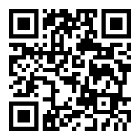
https://alternativeto.net  Commercial website, providing alternatives to proprietary software | https://alternativeto.net
prism-break.org  Open source website, providing alternatives to proprietary software | https://prism-break.org/en/all/

Possible further research
- General Data Protection Regulation (https://www.eugdpr.org/the-regulation.html)
- cryptography
  - against the gathering of meta data: Tor, Proxy, VPN

Role Description: Fictional Caracter in The Circle: Mae Holland
Mae works at the Circle. She praises the company’s community: common activities, events and shared values. By going fully transparent and sharing every moment of her life with millions of followers, Mae embodies the Circle’s three mantras: “Secrets are lies, sharing is caring, privacy is theft.”

You are a seemingly naive Big Data Optimist. You focus on the advantages of social media and Big Data.
You are an educated young adult, aspiring to making the world a better place. You use several apps and wearables, enjoying their ‘free’ content and convenient services. You do not know what data companies have gathered about you and you do not seem to care - since ’you don’t have anything to hide’. You are glad that through social media everybody can create, share, rate, and connect - everybody has a voice. You believe that the analysis of Big Data helps people to become the best version of themselves.

Tasks
Step 1: Read your role card.

Step 2: Do some research.
- Examine the topic of Big Data from the perspective of a Big Data Optimist. You may use the links provided. Do further research, if necessary.
- Collect arguments for and/or against the gathering of Big Data and examples to underline your position.
- In a mind map, collect useful vocabulary and phrases that belong to the world field ‘Big Data’.

During your research you - in your role of a Big Data Optimist - will be invited to participate in a Panel Discussion about Big Data at the University of Oxford. Moderator Viktor Mayer-Schönberger (Professor of the Internet Governance and Regulation at Oxford University) and his team will inform you about the exact discussion question.

Big Data - ?

Guests
- Mercer Medeiros: resists the Circle and its unethical privacy practices.
- Ty Gospodinov: co-founder of the Circle, seeing the danger of the lack of transparency and the accumulation of Big Data.
- Mae Holland: has gone fully transparent, sharing every moment of her life with millions of followers. She values the community of social media.
- Dr. Villalobos: a physician at the Circle’s clinic arguing that Big Data helps to improve healthcare and cure disease.
- Eamon Bailey: co-founder of the Circle, thinking that every company should harness Big Data to better understand their customers and make more profit.

Step 3: Prepare yourselves for the Panel Discussion.
- Use your notes to prepare yourselves for the Panel Discussion. As a team, …
- think of a good opening statement.
- look at your list of arguments and choose the ones you want to put forward in the Panel Discussion. Support your arguments by giving evidence and/or examples.
- discuss how you can react to possible counter-arguments.
- formulate questions to ask the other guests.
- Select a member of your group to be the first representative in the Panel Discussion.

Step 4: Participate in the Panel Discussion.

Links
title, contents | website | QR code
Zuckerberg, Mark. “Building Global Community“, facebook.com, 2/16/2017.  Zuckerberg’s open letter to the Facebook community, explaining how Facebook seeks to make a positive impact on communities | https://www.facebook.com/notes/mark-zuckerberg/building-global-community/10154544292806634/ | 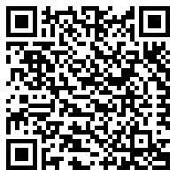
Marr, Bernhard. “Want To Use Big Data? Why Not Start Via Google, Facebook, Amazon, (Etc.)“, forbes.com, 8/14/2017.  Comprehensive article about the upsides of Big Data for consumers | https://www.forbes.com/sites/bernardmarr/2017/08/14/want-to-use-big-data-why-not-start-via-google-facebook-amazon-etc/#103d70c73d5d
Deng, Olivia. “Data Analytics -  March for Our Lives was Born on Social Media“, crimsonhexagon.com, accessed: 4/8/2018.  Analysis of the relation between social movement ‚March For Our Lives‘ and social media | https://www.crimsonhexagon.com/blog/march-for-our-lives-was-born-on-social-media/ | 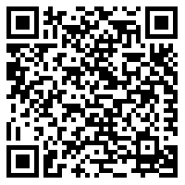
NBC News. “Why Netflix’s Algorithm Is So Binge-Worthy | Mach | NBC News“, youtube.com, 4/25/2017  3-minute video, explaining Netflix’ individual recommendations through algorithms - for customers’ convenience | https://www.youtube.com/watch?v=nq2QtatuF7U
Ben-Shahar, Omri. “Opinion: Privacy is the New Money, Thanks to Big Data“, forbes.com, 4/1/2016.  Opinion piece by a Chicago Law Professor about people’s indifference about Big Data collection and the ‘free' use of online services | https://www.forbes.com/sites/omribenshahar/2016/04/01/privacy-is-the-new-money-thanks-to-big-data/#578027783fa2

Role Description: Fictional Caracter in The Circle: Dr. Villalobos
Dr. Villalobos is a physician at the Circle’s clinic responsible for the biweekly check-ups of the Circlers. Her work is based on the guiding principle behind healthcare at the Circle: “To heal we must know. To know we must share.”

You are passionate about the intersection between medicine and technology to facilitate research and improve healthcare. You are firmly convinced that Big Data analytics provide valuable insights into medicine and health, reduces costs or helps to cure diseases. You are of the opinion that a lot of important medical questions could be answered with the help of Big Data. You just have to figure out what questions to ask.

Tasks
Step 1: Read your role card.

Step 2: Do some research.
- Examine the topic of Big Data from the perspective of a Big Data Advocate. You may use the links provided. Do further research, if necessary.
- Collect arguments for and/or against the gathering of Big Data and examples to underline your position.
- In a mind map, collect useful vocabulary and phrases that belong to the world field ‘Big Data’.

During your research you - in your role of a Big Data Advocate - will be invited to participate in a Panel Discussion about Big Data at the University of Oxford. Moderator Viktor Mayer-Schönberger (Professor of the Internet Governance and Regulation at Oxford University) and his team will inform you about the exact discussion question.

Big Data - ?

Guests
- Mercer Medeiros: resists the Circle and its unethical privacy practices.
- Ty Gospodinov: co-founder of the Circle, seeing the danger of the lack of transparency and the accumulation of Big Data.
- Mae Holland: has gone fully transparent, sharing every moment of her life with millions of followers. She values the community of social media.
- Dr. Villalobos: a physician at the Circle’s clinic arguing that Big Data helps to improve healthcare and cure disease.
- Eamon Bailey: co-founder of the Circle, thinking that every company should harness Big Data to better understand their customers and make more profit.

Step 3: Prepare yourselves for the Panel Discussion.
- Use your notes to prepare yourselves for the Panel Discussion. As a team, …
- think of a good opening statement.
- look at your list of arguments and choose the ones you want to put forward in the Panel Discussion. Support your arguments by giving evidence and/or examples.
- discuss how you can react to possible counter-arguments.
- formulate questions to ask the other guests.
- Select a member of your group to be the first representative in the Panel Discussion.

Step 4: Participate in the Panel Discussion.

Links
title, content | website | QR code
BBC: “Will 'big data' prevent disease?,” bbc.com, 11/18/2014.  A short interview with Linda Avey, genetics entrepreneur, on the question of whether Big Data can cure disease. | http://www.bbc.com/future/story/20121212-will-big-data-cure-disease
Madan, Amol: “Your Smartphone, Your Therapist?”, huffingtonpost.com, 1/23/2016.  An article about Ginger.io, a smartphone app developed by data scientists from MIT that predicts when patients with mental illnesses are symptomatic and offers emotional support and care. | https://www.huffingtonpost.com/anmol-madan/your-smartphone-your-therapist_b_9054156.html | 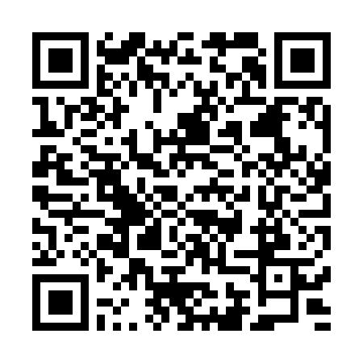
Cha, Ariana Eunjung: “Health and Data: Can Digital Fitness Monitors Revolutionise Our Lives?”, theduardian.com, 5/19/2015.  An article about the benefits and possible dangers of health-tracking technology (including a fantastic illustration of health-monitoring devices). | https://www.theguardian.com/society/2015/may/19/digital-fitness-technology-data-heath-medicine | 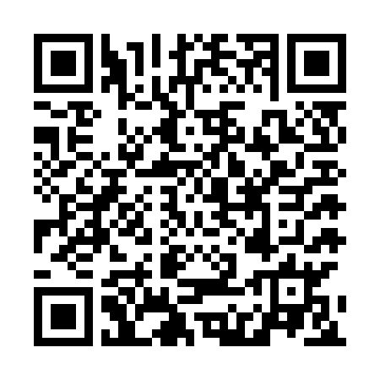
Altman, Russ: “What really happens when you mix medications?”, tedmed.com, 2015.  Russ Altman, professor of bioengineering, genetics, medicine, and biomedical data science, explains how Big Data could help to understand drug interactions. | https://www.tedmed.com/talks/show?id=529433

Possible further research
- predictive healthcare
- wearable technology

Role Description: Fictional Character in The Circle: Eamon Bailey
Eamon Bailey is one of the founders of the Circle. He is a charismatic and confident speaker and the public face of the company. Bailey and his wife have four children, three girls and a boy born with cerebral palsy. Bailey believes in total transparency and is convinced that people should surrender their privacy to the company.

You argue that all companies, whether big or small, need to take Big Data seriously as it offers considerable benefits to both consumers and companies. Big Data Analytics help companies to make more informed business decisions, improve their marketing strategy or make better pricing decisions. In short, Big Data means big profit. In return, customers or users get free apps or products that are tailor-made to their needs. Thus, it is no surprise that they happily share their personal data.

Tasks
Step 1: Read your role card.

Step 2: Do some research.
- Examine the topic of Big Data from the perspective of a Big Data Expert. You may use the links provided. Do further research, if necessary.
- Collect arguments for and/or against the gathering of Big Data and examples to underline your position.
- In a mind map, collect useful vocabulary and phrases that belong to the world field ‘Big Data’.

During your research you - in your role of a Big Data Expert - will be invited to participate in a Panel Discussion about Big Data at the University of Oxford. Moderator Viktor Mayer-Schönberger (Professor of the Internet Governance and Regulation at Oxford University) and his team will inform you about the exact discussion question.

Big Data - ?

Guests
- Mercer Medeiros: resists the Circle and its unethical privacy practices.
- Ty Gospodinov: co-founder of the Circle, seeing the danger of the lack of transparency and the accumulation of Big Data.
- Mae Holland: has gone fully transparent, sharing every moment of her life with millions of followers. She values the community of social media.
- Dr. Villalobos: a physician at the Circle’s clinic arguing that Big Data helps to improve healthcare and cure disease.
- Eamon Bailey: co-founder of the Circle, thinking that every company should harness Big Data to better understand their customers and make more profit.

Step 3: Prepare yourselves for the Panel Discussion.
- Use your notes to prepare yourselves for the Panel Discussion. As a team, …
- think of a good opening statement.
- look at your list of arguments and choose the ones you want to put forward in the Panel Discussion. Support your arguments by giving evidence and/or examples.
- discuss how you can react to possible counter-arguments.
- formulate questions to ask the other guests.
- Select a member of your group to be the first representative in the Panel Discussion.

Step 4: Participate in the Panel Discussion.

Links
title, contents | website | QR code
Marr, Bernard: “4 Ways Big Data Will Change Every Business”, forbes.com, 9/8/2015.  Bernard Marr points out how data is revolutionizing the world of business. | https://www.forbes.com/sites/bernardmarr/2015/09/08/4-ways-big-data-will-change-every-business/#4dc622bb2729 | 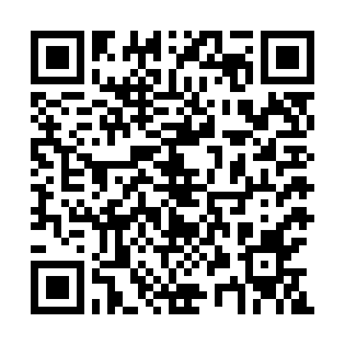
IBM Analytics: “Big Data, Big opportunities for Marketing”, youtube.com, 7/18/2013.  A promotional video from IBM about how Big Data analytics can be used to improve marketing. | https://www.youtube.com/watch?v=xJfP_o_fANA
Big Think: “How Amazon’s Algorithm Gets You to Spend Money“, youtube.com, 8/19/2015.  Jerry Kaplan, author and entrepreneur, explains how websites like Amazon study consumer behaviour to maximize their profits. | https://www.youtube.com/watch?v=GSAz0vVfVmo
Sinha, Gunjan: “The Power of Intelligence”, huffingtonpost.com, 12/21/2016.  An insightful article summarizing several benefits of big data not only for companies. | https://www.huffingtonpost.com/gunjan-sinha/the-power-of-intelligence_b_13752044.html | 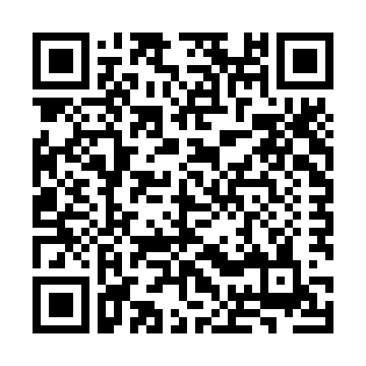
Marr, Bernard: “The Amazing Ways Instagram Uses Big Data and Artificial Intelligence”, forbes.com, 3/16/2018.  Helpful insights into how Instagram uses big data to enhance its platform for both users and advertisers. | https://www.forbes.com/sites/bernardmarr/2018/03/16/the-amazing-ways-instagram-uses-big-data-and-artificial-intelligence/#5d5f73db5ca6 | 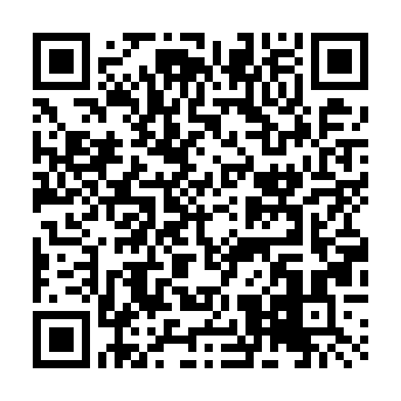
Post, Rachael: “Ford and Nike use big data to make smarter sustainable design”, guardian.com, 2/18/2014.  An article about two companies rethinking products’ sustainability using big data. | https://www.theguardian.com/sustainable-business/ford-nike-big-data-smart-sustainable-design
Possible further research: articles by Bernard Marr (forbes.com); companies (successfully) using big data: Facebook, Amazon, Google, Netflix, Spotify, Apple, Microsoft, Uber…

Role Description: Viktor Mayer-Schönberger
Viktor Mayer-Schönberger is the Professor of Internet Governance and Regulation at Oxford University. He studied in Salzburg, Harvard and London and founded Ikarus Software, a company focusing on data security. He has published several books, including the international bestseller Big Data: A Revolution That Will Transform How We Live, Work, and Think (co-authored with Kenneth Cukier, 2013) and is a frequent public speaker and expert for big data.
(cf. https://www.oii.ox.ac.uk/people/viktor-ms/, accessed: 4/8/2018)

Your task is to moderate the Panel Discussion. Your guests are:
- Mercer Medeiros: resists the Circle and its unethical privacy practices.
- Ty Gospodinov: co-founder of the Circle, seeing the danger of the lack of transparency and the accumulation of Big Data.
- Mae Holland: has gone fully transparent, sharing every moment of her life with millions of followers. She values the community of social media.
- Dr. Villalobos: a physician at the Circle’s clinic arguing that Big Data helps to improve healthcare and cure disease.
Eamon Bailey: co-founder of the Circle, thinking that every company should harness Big Data to better understand their customers and make more profit.

Viktor Mayer-Schönberg
(Cukier, Kenneth and Viktor Mayer-Schönberger. Big Data: The Essential Guide to Work, Life and Learning in the Age of Insight. London: John Murray. 2013.)
“In fact, with the right mindset, data can be cleverly reused to become a fountain of innovation and new services. The data can reveal secrets to those with the humility, the willingness, and the tools to listen.”

by re:publica/Gregor Fischer
Viktor Mayer-Schönberger - re:publica 2014, Tag 2, 5/7/2014, CC BY-SA 2.0
(at https://bit.ly/2GMSZN6 (shortened URL), accessed 8/4/2018)

Jay Walker about Big Data:
(The Human Face of Big Data. Directed by Sandy Smolan. 2014. https://www.youtube.com/watch?v=m9D-v6r3NJQ, 03:23-03:35, accessed 8/4/2018)
"Every powerful tool has a dark side. Every last one. Anything that is going to change the world by definition has to be able to change it for the worse as much as for the better. It doesn’t work one way without the other.“
Tasks
Step 1: Read your role card.

Step 2: Do some research.
- Examine the topic of Big Data from the perspective of a neutral moderator. You may use the links provided. Do further research, if necessary.
- In a mind map, collect useful vocabulary and phrases that belong to the world field ‘Big Data’.
- During your research you should come up with a controversial question for the Panel Discussion. Invite your guests and inform them about the exact topic:

Big Data - ?

As a team of moderators you can also inform yourselves about the other groups without disturbing them. You might want to listen and watch or ask a question.

Step 3: Prepare yourselves for the Panel Discussion.
- Use your notes to prepare yourselves for the Panel Discussion. As a team, …
- prepare an introduction to the topic that arouses the interest of the audience. Your introduction should also include a definition of the term Big Data.
- formulate questions to ask your guests and the audience during the Panel Discussion.
- think of impulses to activate the members of the panel in case the discussion slows down.
- Select a member of your group to be the first representative in the Panel Discussion.

Step 4: Participate in the Panel Discussion. Make sure to stay neutral and to keep the conversation going.

Links
title, contents | website | QR code
Marr, Bernard: “What is Big Data? A Super Simple Explanation For Everyone”, bernardmarr.com.  Bernard Marr on Big Data, how it works and how it is being used. | https://www.bernardmarr.com/default.asp?contentID=766
Cukier, Kenneth: “Big Data is Better Data”, ted.com, 2014.  Kenneth Cukier explains why the big in the term Big Data is important and looks at the benefits and dark sides of Big Data. | https://www.ted.com/talks/kenneth_cukier_big_data_is_better_data/discussion?rss
THNKR: “The Dangers of Big Data”, youtube.com, 4/16/2013.  Rick Smolan discusses the power of big data as well as issues of privacy and discrimination. | https://www.youtube.com/watch?v=y8yMlMBCQiQ
Marr, Bernard: “How is Big Data used in practice? 10 use cases everyone must read”, bernardmarr.com.  A list of 10 major areas in which big data is used. | https://www.bernardmarr.com/default.asp?contentID=1076

