terminology | branching | parallel paths | threaded | dynamic/object-oriented narrative
visualization | 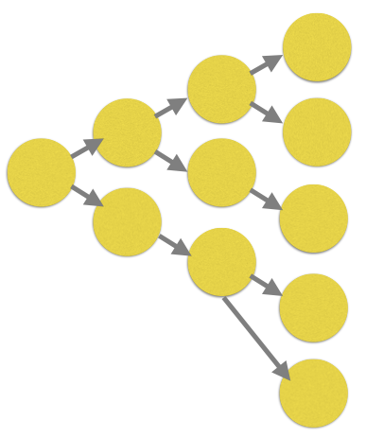 | 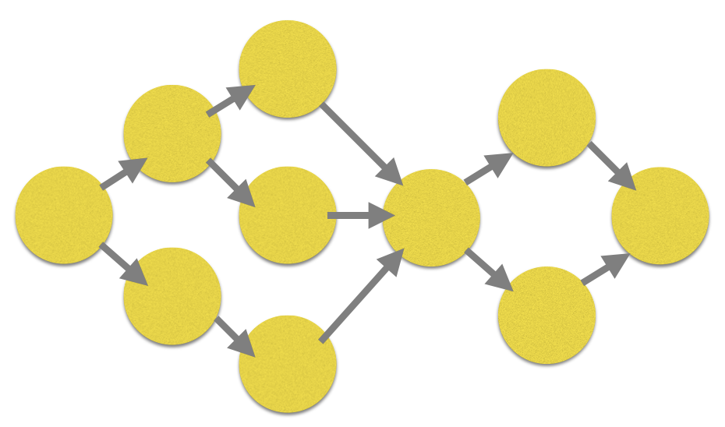 | 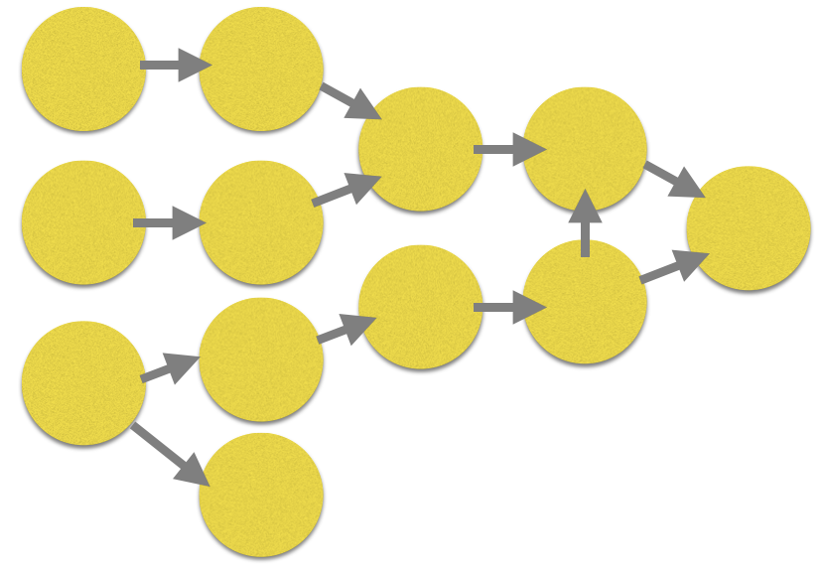 | 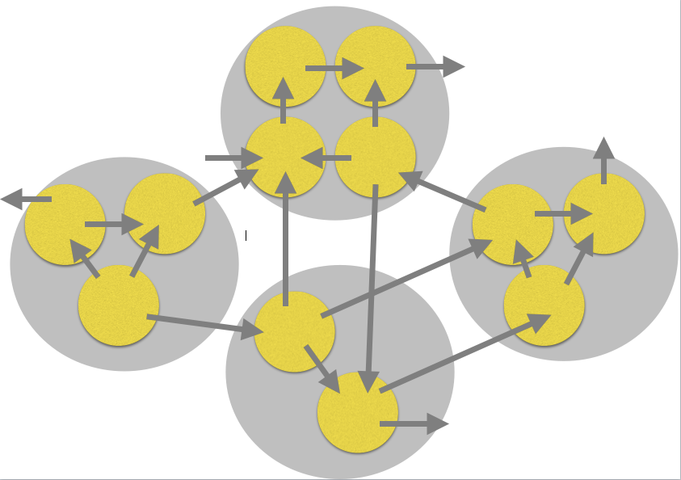
explanation | - interactive,  - choice points given in the game  - story follows one path until another choice point is reached | - player can make choices  - all choices lead to several mandatory events  - choices may lead to additional story elements  - players’ choices may influence the ending | - story is divided into small pieces  - these small pieces may intersect  - different narratives are possible at the same time  - players can choose the paths and sometimes the order of the paths | - consists of different mini-stories (like chapters of a novel or acts in a play)  - mini-stories have several entry points and exit points (unlike chapters or acts)  - exit points can lead to another mini-story or final ending (unlike chapters or acts)  - the players’ choices determine the order of the mini-stories (unlike chapters or acts)
advantages | easiest level of writing non-linear stories (which is still difficult) | not as many stories have to be written | complex | intertwined chapters can be written, also cooperatively
possible difficulties | - many story lines have to be written  - the player/reader does not see/read all of them | the narrative is linear | - writing a threaded narrative is difficult because events can happen in any order  - any order of the narratives needs to be logical, so the players do not get confused | very complex

The information is adapted from: “Game Design Concepts - An experiment in game design and teaching“ by Ian Schreiber: https://gamedesignconcepts.wordpress.com/2009/07/30/level-10-nonlinear-storytelling/ (http://t1p.de/c3eg) (Game Design Concepts by Ian Schreiber is licensed under a CC BY 3.0 US)

