Task

**Create your own mBook about your “dream holiday”.**

* Work with a partner.
* Have a look at the example [QR-Code A] again, before you start working.



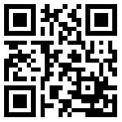<http://t1p.de/46pi>

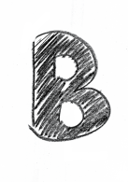

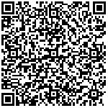

**<http://t1p.de/3vlt>



.

* You can also add pictures, sound and video. If you need help, watch the explanatory video again [QR-Code C].



* You should write at least three sentences on every page.
* If you need some ideas for your sentences, check QR-Code B.
* Use simple past tense.



* Present your mBook to the class.

